**Curriculum Vitae**

***HILDA CLEMENCIA MARY A***

**Mobile: 8870366843 &**

**8220956803**

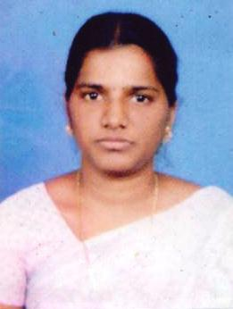

**H/O C. Paul Anand**

**68, Kumarapillai St.,**

**Kottucherry (po),**

**Karikal (Dt)**

**Puducherry- 609609**

**OBJECTIVE**

To work in an organization to enhance my knowledge and skills with total dedication and contribute the best of my efforts to achieve the goals of the organization.

**EXPERIENCE ( 5Years & 7 Months)**

* Teaching in S.S.A. from E.V. Teacher ( R.C. Morning Star ) Kumbakonam. From June-2010 to March 2012 (2 Years)
* Teaching in Servite Hr. Sec. School, Karaikal . From June-2012 to May 2015

(3 Years)

* Teaching in Galaxy Indian School, Karaikal . From June-2018 to January-2019

(7 Months)

# Educational Qualification

|  |  |  |  |  |
| --- | --- | --- | --- | --- |
| Course | Main Subject | School/College | Board/University | Year of Passing |
| D.T.ED. | All | St. Theresa Teacher Training Institute , Thanrangambadi | Tamil Nadu | 2009 |
| B.A. | Tamil | Distance Education | Bharathidasan University | 2013 |

# Additional Qualification

* Ms-office ( Ms-word, Ms-Excel)
* Good Typing Skill

# Additional Qualification

* Football in District Champion ( School Level )
* Football in Division Runners ( School Level )

# Personal Details

* Name : HILDA CLEMENCIA MARY A
* Husband Name : Paul Anand C
* Nationality : Indian
* Date of Birth : 03.06.1989
* Gender : Female
* Marital Status : Married
* Language Known : English & Tamil.

# Abilities

* Self-motivated & capable to mix easily with different situation
* Hard Worker and Honest
* Disciplined and Team Worker
* Perform Assigned task with grant responsibility
* Sincere and result oriented & Good Communication skills

Declaration

I hereby declare that the information furnished above is true to the best of my knowledge

And belief

Place: Kottucherry

Date: - **(HILDA CLEMENCIA MARY A)**